Introduction:

I have joined the Hot Beans Web company as a new web development and I need to create a website for the employer has asked me to update the website using the HTML skills. It needs to have a lot of features, like job descriptions, a list of existing employees, a thorough company profile, the required degrees and a submission form. In addition to begin official, each of these traits needs to have an engaging design that makes proper use of style and colours and unifying theme, as a user intuitive interface.

I have been requested to develop five navigations the names of the navigations:

Home – About Us – Course – Contact Us – Apply

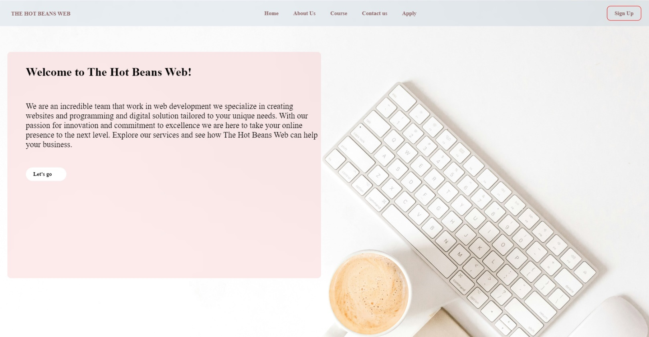1 Home page:

In the home page I have created a box with a light pink colour to be visible for the user and that box have an introduction and welcoming to make the user understand in a small brief about the website and in the top, there is a navigation bar it has all the buttons to be send between the pages.

The colour of the background is between white and light pink and light Gray.

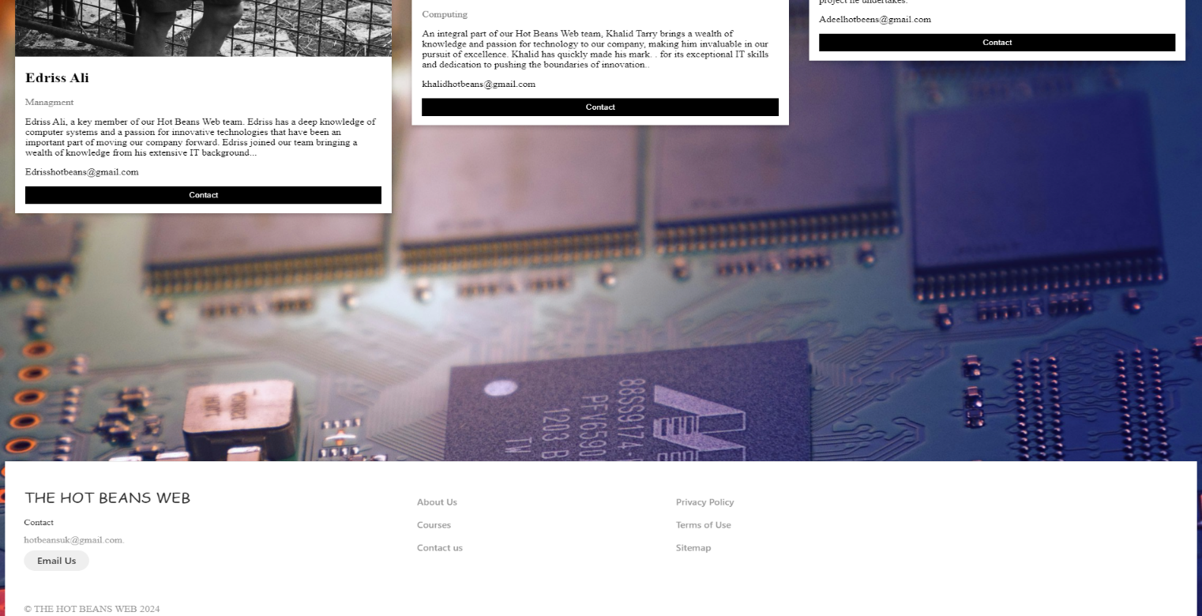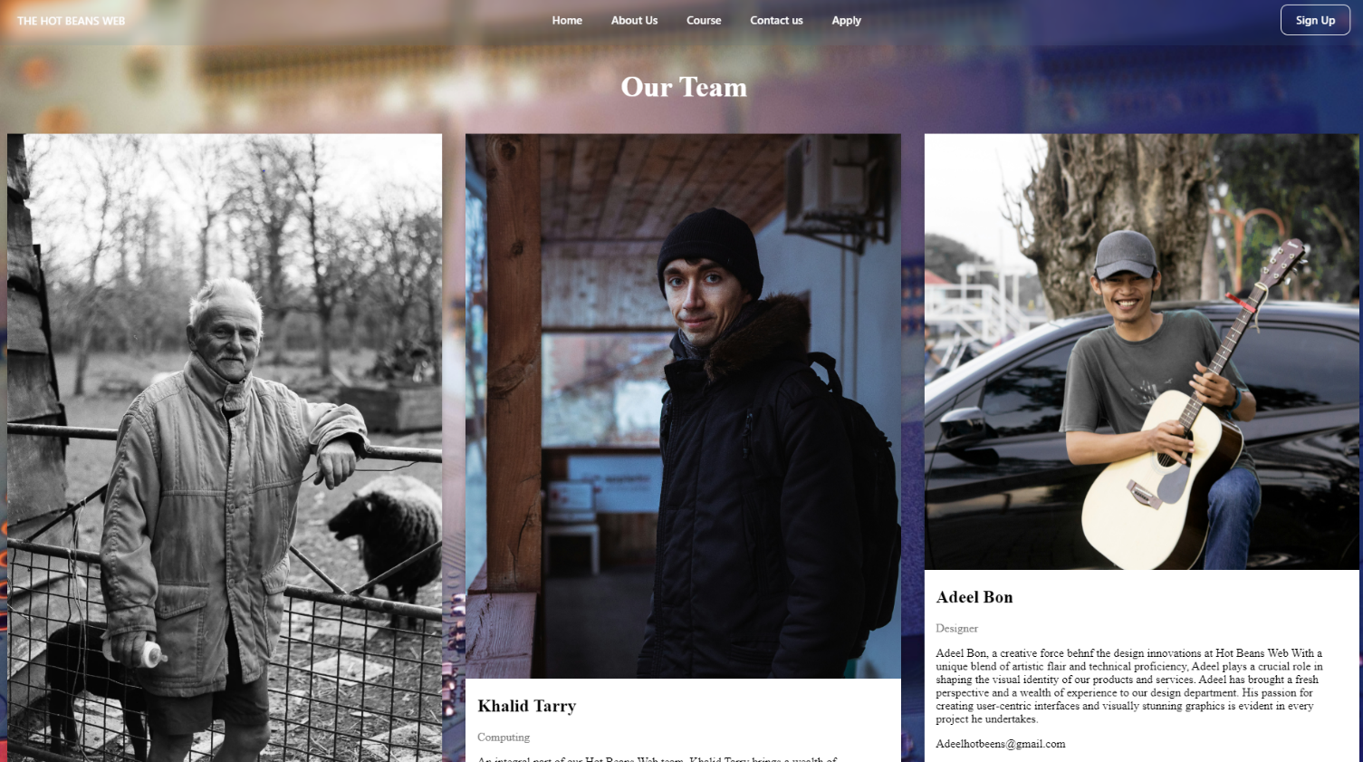2 About Us:

There is a picture and small summary about the team members and there Is a contact button to reach the staff and the rest of the page is titles in the page and in the top of the page and in the bottom of the page it’s a faction button.

The colour of the background is blurry colours about blue and white and black.

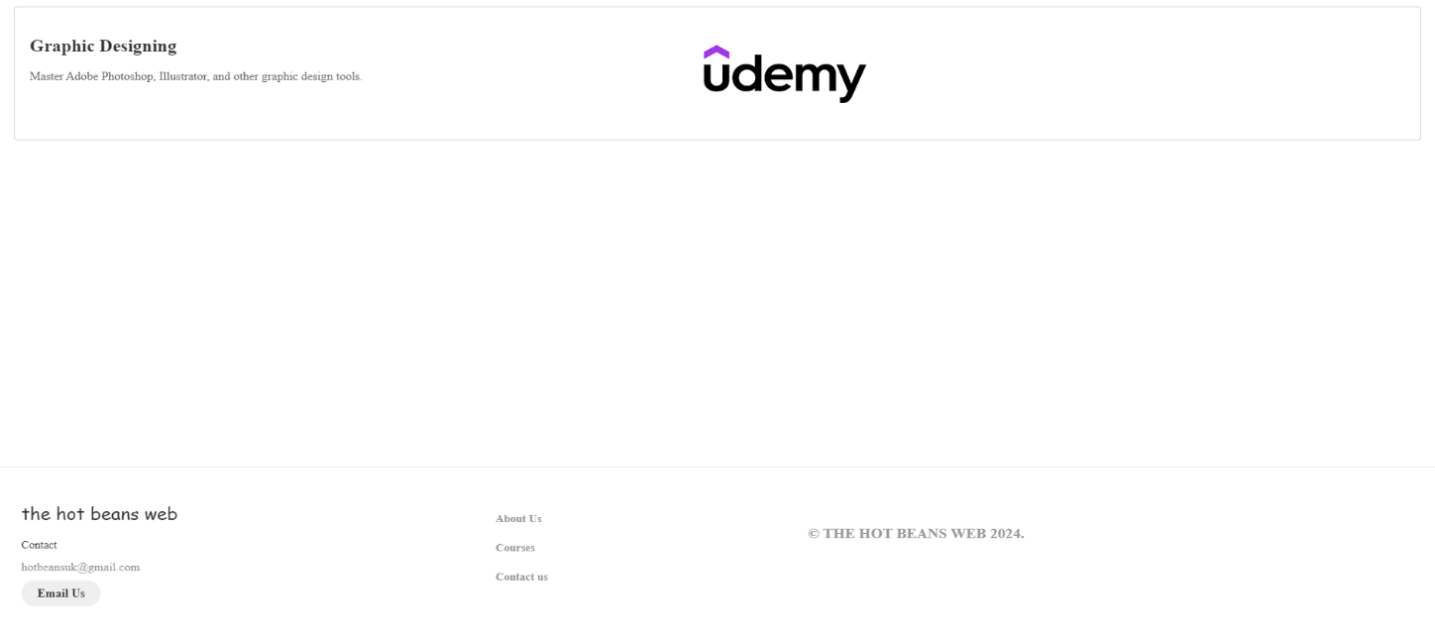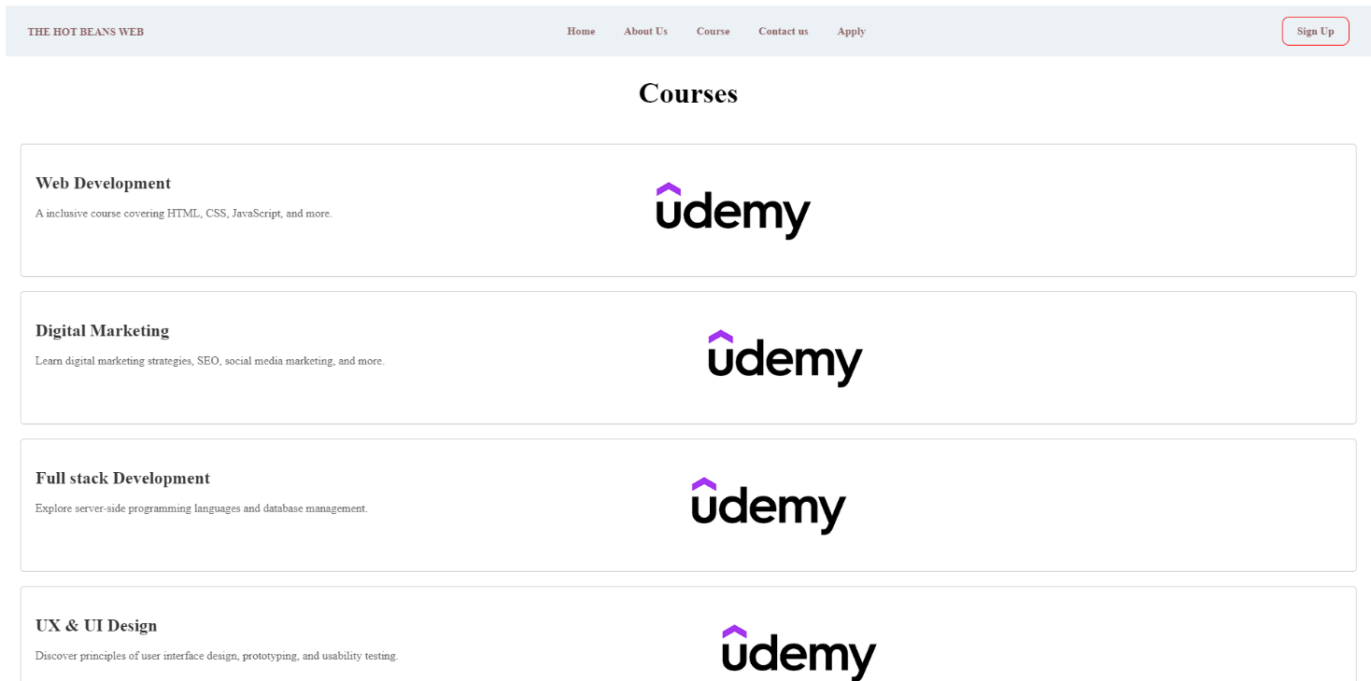3 Course:

The page’s text will sit in the middle, and the background will be a white page with small squares that they have the course name and a summary about the course and there is a link to send you to the course page and all the buttons and functioned.

Background colour is white with a black text.

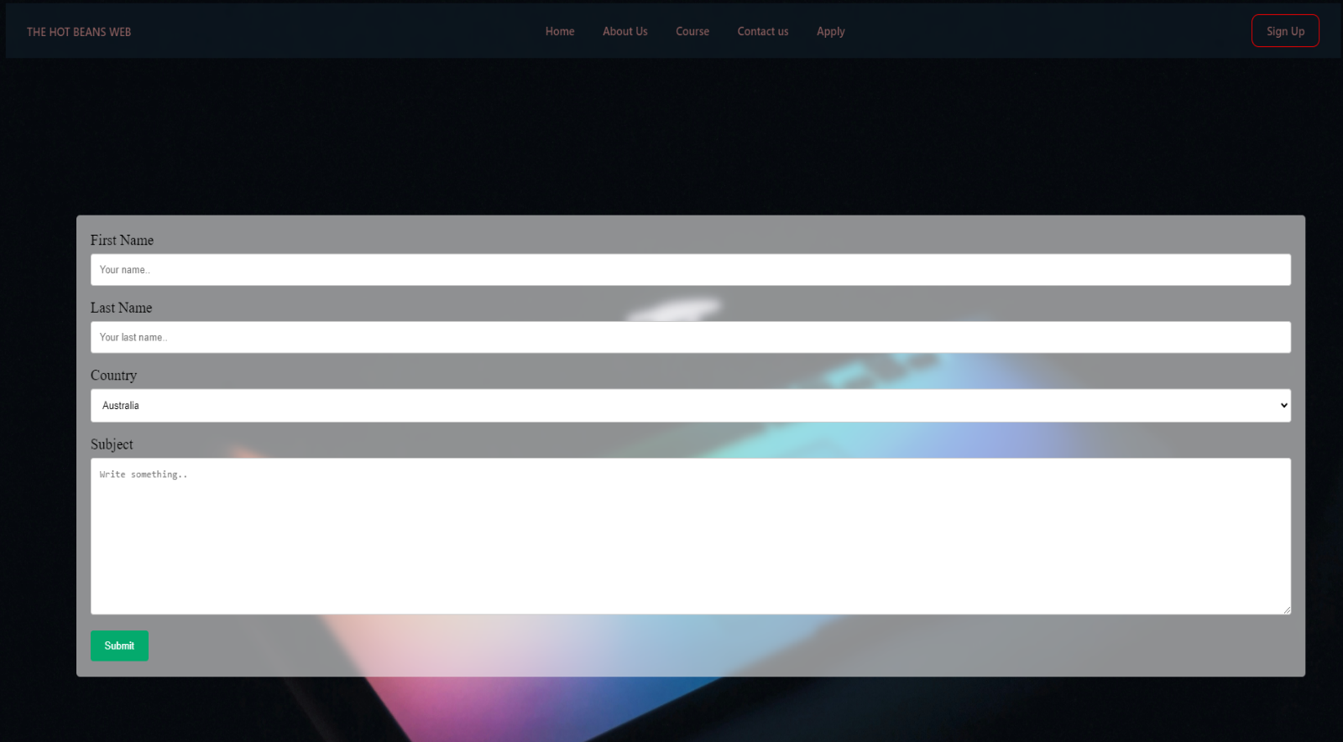4 contact us:

In the top there will be the links it set in the nav bar this is the contact page to there will First name and the Last name – country and the subject

The background colour is black and in the middle is a laptop that open half way and have different colour.

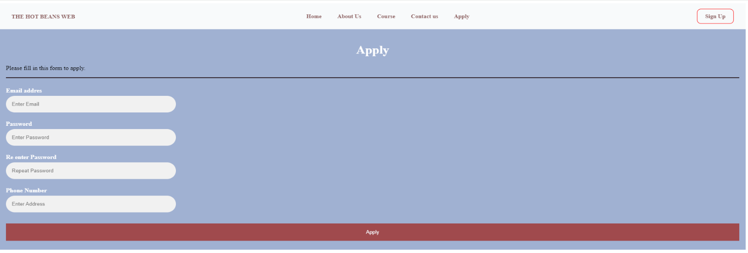5 Apply:

In the top is the navigation bar and it will be for the apply page including Email, Password, Re-enter password, Phone number.

The background in a light blue colour to give a different look for the website and apply button at the bottom to save the data.

Some of the audience response I have gotten them two choices and they selected one. Based on their input, that am creating a website for the hot beans business

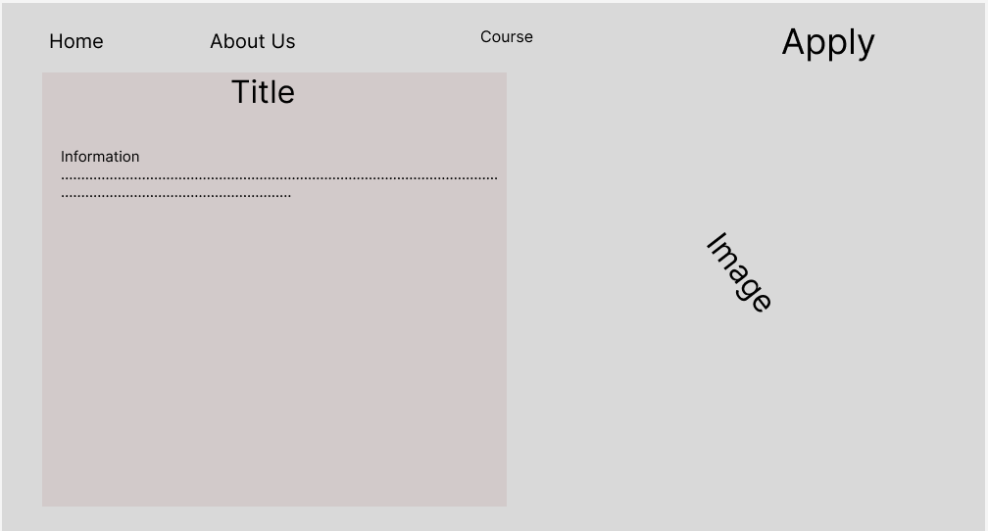 Design 1:

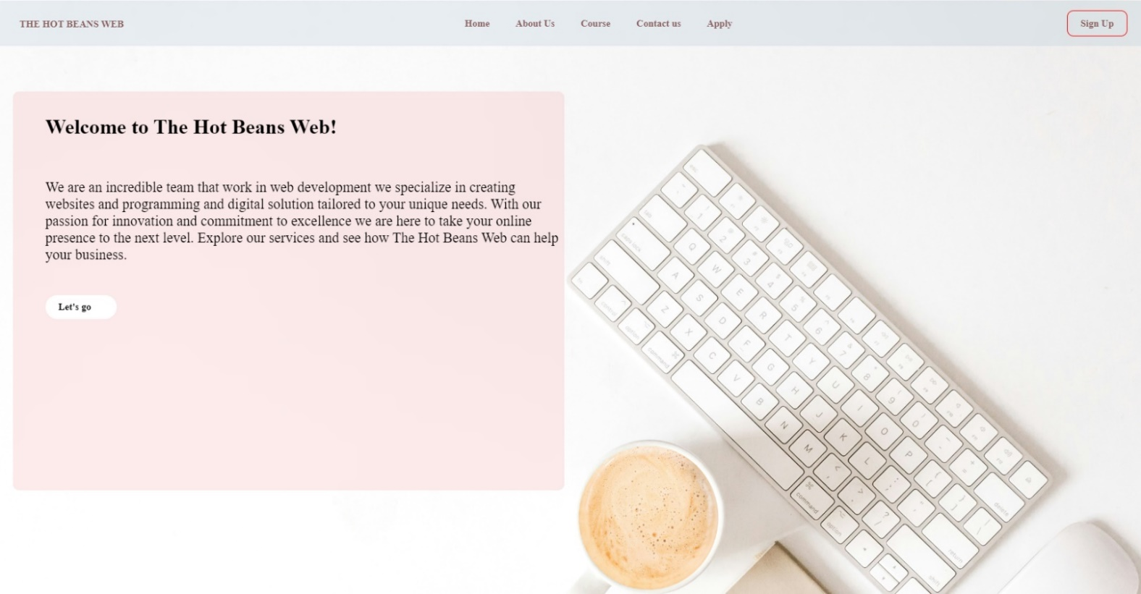 Design2:

This is the final edit for the design I have included more functions button and made the navigation bar more suitable for the user to understand.

Shah Aadil Kamali (19199080)

The first design the background colour is really dull and boring. The second design is more colourful and more appropriate. The first design I don’t understand what’s going on and don’t understand what the website is about and what is going on. But on the second design I understand what is going on and what the website Is about, what the website is trying to do.

Nazmul Islam (19089796)

The first design I think it’s too dark it’s not visible to the customer and the back grounds ground its not looking suitable for a website in the other picture the brightness is high because of the white colour it makes it clearer and also there is so introduction message in the home page not like the other one there is no introduction in the home page and it’s not understandable.

Adeel Hassan (19156191)

In the first design the design of the home page nav bar looking un organized for the customer it’s kind of jumping in not organized way but in the second picture it looks organized and its clearer for the user.

Mohtaj Islam (19199875)

In my opinion the final design is a lot more better looking than the first design, the colours don’t look pleasant to people and there’s no white space or content in the first design. Instead in the final design the colours match to look pleasant, and everything is organized using white-space and finally it has content.

Annotation of Home page:



This written logo is for the Hot Beans Web it’s function to be clickable to send you to the mane home page it made from bold font and light pink colour

This is the navigation bar it was designed to go to other pages and operates by clicking on each navigation bar unique link. And they in a size that can be seen and in a visible colour.

It’s a box that have a small brief about the website and it have a function button to click and send you to the starting page for accessing the website.

Annotation About us page:

This written logo is for the Hot Beans Web it’s function to be clickable to send you to the mane home page it made from bold font and it’s in white colour.

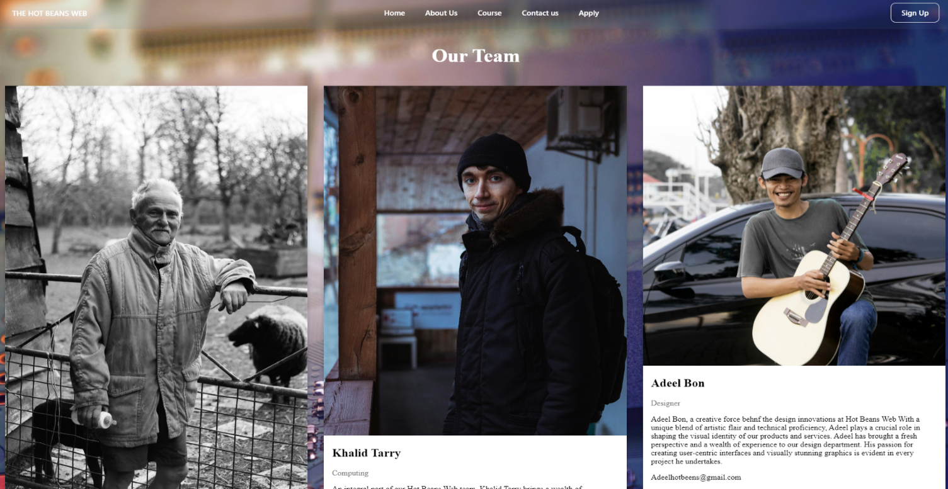

This written logo is for the Hot Beans Web it’s function to be clickable to send you to the mane home page it made from bold font and in white colour.

This is the part with the hot bean web team members profiles. This section primary goal is to provide information on the team members and there are pictures for the team’s members.

This is another navigation bar have titles to send you to the other pages and also the hot beans web contacts and policy for the company

This written logo is for the Hot Beans Web it’s function to be clickable to send you to the mane home page it made from bold font and it’s in light pink colour.

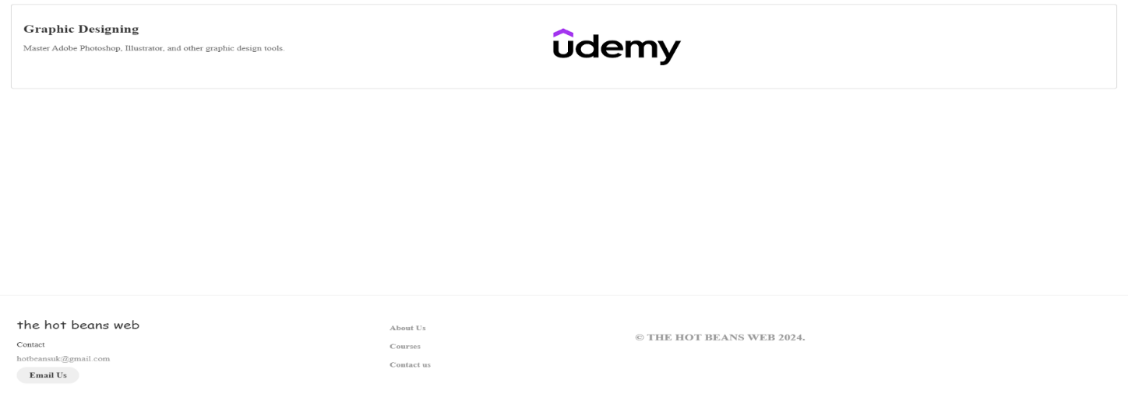Annotation Course page:

This is the courses for the Hot Beans Web links to job sites and other pertinent information and small brief about the course. The job site logos are annotated externally on the pages to directing users to the appropriate websites upon clicking on them.

This written logo is for the Hot Beans Web it’s function to be clickable to send you to the mane home page it made from bold font and in white colour.

This is another navigation bar have titles to send you to the other pages and also the hot beans web contacts and policy for the company.

Annotation Contact us page:

This written logo is for the Hot Beans Web it’s function to be clickable to send you to the mane home page it made from bold font and it’s in light brown colour.



This is a contact us page where the user can contact with the company by using the contact us page and its in white colour so it can be discernible for the user.

This written logo is for the Hot Beans Web it’s function to be clickable to send you to the mane home page it made from bold font and in black colour.

Annotation Apply page:

This written logo is for the Hot Beans Web it’s function to be clickable to send you to the mane home page it made from bold font and in white colour.

This written logo is for the Hot Beans Web it’s function to be clickable to send you to the mane home page it made from bold font and it’s in light pink colour.

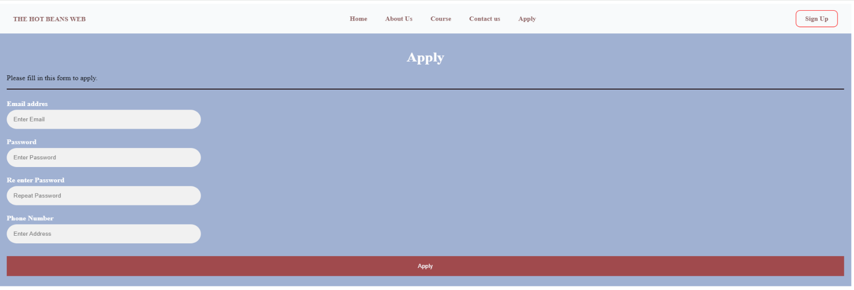

This is the apply page for the hot beans web for the users to apply for the website and it’s had the minimum apply information and the colours are in white so it will be visible for the user.

Optimised website (Mobile devices):

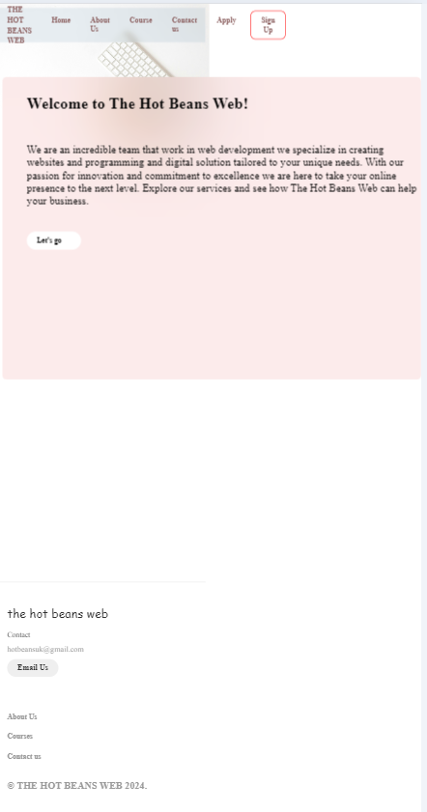

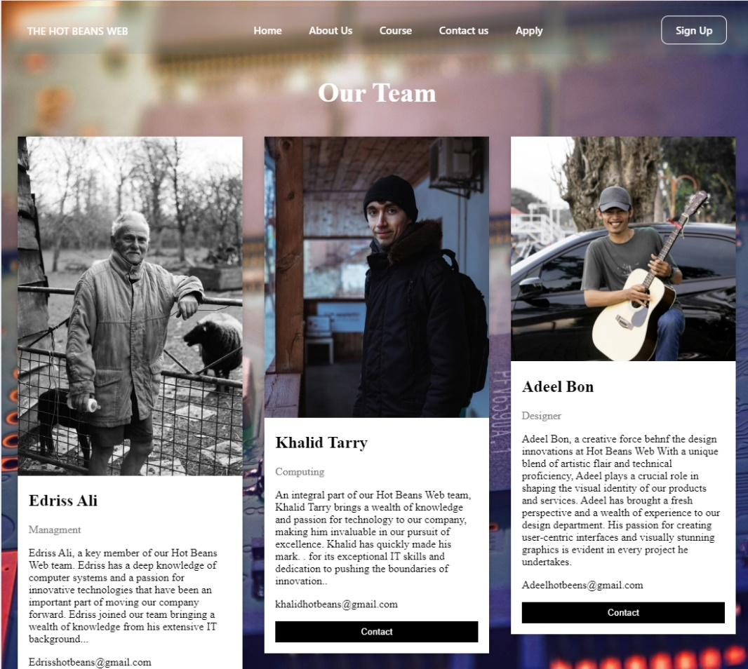

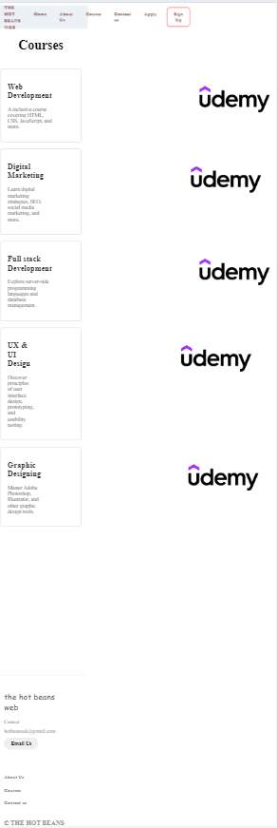

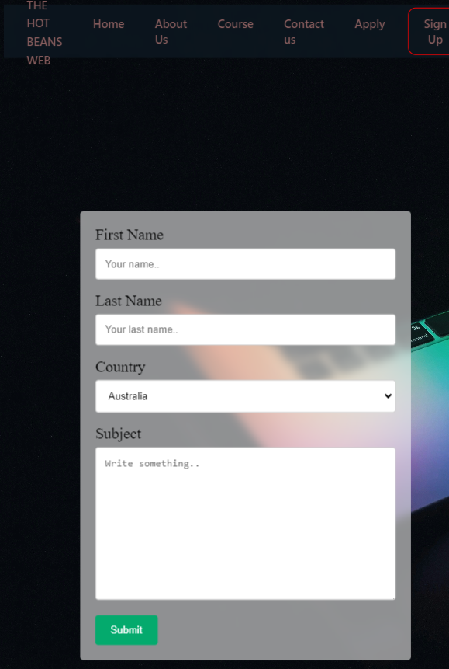

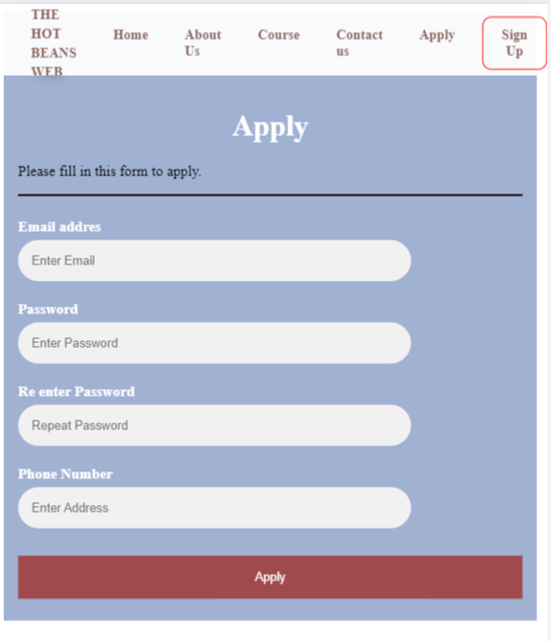

This represent my entire mobile work, and the layout is perfect. These documents are all operating as intended.

|  |  |  |  |  |  |
| --- | --- | --- | --- | --- | --- |
| No. | Test description | Expected outcome | Actual outcome | Action | Comment |
| 1 | Hot beans web logo | I should b able to access the home page by clicking on the logo | Yes, it was successful it took me back to the home page | N/A |  |
| 2 | Navigation bar | The page should be accessible through the navigation bar | Yes the results came successful it send me t the correct page | N/A |  |
| 3 | Course links | Upon clicking the course link, I should be directed to the course | Yes the outcome came successful it direct me to the page | N/A |  |
| 4 | Apply page form | Once I submit the form, I should be able to register | Indeed I was able t successfully register and outcome was as follows | N/A |  |
| 5 | Images loading | Are all the sites photos loading correctly | All of the images hey load loads correctly without issue | N/A |  |
| 6 | Register validation | The password should not appear as shown or hidden when entering password | The password is visible when completing the form, which is why the outcome is negative | I have modified the input type to a password instead of text |  |

EVALUATION:

I was asked to design a website based on the specification provided by the client.

To construct the website, a number of requests and specifications have been made. Using Figma, I had to develop two distinct websites as one of the criteria. I must request for input from the audience after designing two distinct websites, and they will pick the one they believe has the best design. Additionally, if the audience requested that I revise the design, I would have to do it in order to suit their needs. Using Figma, I produced a distinct design that I exhibited to others in order to gain their opinion. I have chosen the design based on the comments I received from the largest amount of people, and I will begin adhering to the remaining requirements after that. The website has to have a minimum of five pages, according to the second regulation. I made a five-page website, and on those pages, I answered a request for information about Hot Beans Web. The implementation of a navigable and efficient system that would connect all five pages was another essential requirement. To guide users to every page on the website, I created a navigation system.  
I was also required by the website to provide information about the business and its personnel. A page where users can register for this company needs to be created. I have chosen to divide all of individuals into distinct pages and give them names in order to comply with the requirement. For instance, on HOME PAGE, I have included facts about the company, and on the about us page, called ABOUT US page I created the Hot Bean Web company's team.  
  
Information about every COURSE offered on the Hot Beans Web is provided on this course page.  
And there is a page for CONTACT US so he can reach the company and ask about any questions they got or any other requirements they need.   
APPLY page is where the use can apply for the HOT BEANS WEB for example, he needs to write his Email, Password, Re-enter password, phone number.   
  
Following that, I created five distinct designs for each page, and I then created the website based on the design and the specifications. I then finished building Hot Bens Web's website.

My personal plan:

|  |  |  |  |  |
| --- | --- | --- | --- | --- |
| **Task description** | **Estimated Duration in hours** | **Actual duration** | **Target completion date** | **Actual completion date** |
| * **Website designing** * **Taking review from audience and upgrading the design** | **4 days** | **2 days** | **14/04/2024** | **20/04/2024** |
| * **Justification plan** | **2h** | **3 days** | **17/04/2024** | **24/04/2024** |
| * **Creating website and linking it** | **10 days** | **2 days** | **21/04/2024** | **21/04/2024** |
| * **Testing website** * **Making it mobile version** | **1 day** | **1 day** | **21/04/2024** | **22/04/2024** |
| * **Annotation** | **2H** | **6h** | **22/04/2024** | **22/04/2024** |
| * **Fix website that failed to link in testing** | **1h** | **4h** | **22/04/2024** | **24/04/2024** |
| * **Evolution of the assignment** * **Responsibility** * **Time management** | **4 days** | **2 days** | **04/05/2024** | **25/05/2024** |
| * **Linking to GitHub** | **1 day** | **1 day** | **24/05/2024** | **12/06/2024** |

**Justification:**

I've decided to make the website better by accurately and legibly structuring everything. I've also included a good bit of white space within the format, which makes the page both very detailed and easy to read. A paragraph outlining the company's mission and purpose is included on the front page, which serves as an introduction to the website for visitors. To make it even easier to read, the website makes good use of white space and has a simple layout.

The page has been organised to highlight the company's top employers and provide a clearer explanation of some of the services that Hot Beans Web provides. The About Us section is concise and comprehensive. For the purpose of creating a linear visual effect, the page features three tables that uniformly split the most significant responsibilities inside the firm.

Courses: This page contains a 3-table structure with the various particular courses and interactive links that take users to the official websites of the various courses. The page was built to provide users with the various courses that can assist users better understand the work of the web developer.

Contact us it was created to make the user can communication with the company and make it easier then go and send email wile he can make it through the website to contact the Hot Beans Web.

Apply page Use this The purpose of the page is to provide users with the option to Apply for Jobs at Hot Beans Web and the jobs that it offers. With numerous tables and sections where visitors can fill in the relevant facts, the website is formatted similarly to any registration form.

Website link .

<https://moed19107946.github.io/Hot-Beans-Web-/>